# SharePoint 2013 Demo – Structured Content & Managed Navigation

## Estimated time to complete this demo

35 minutes (15 minutes if the first demo is completed before class)

## Objectives

This demo uses virtual machines as described in the following table. Before you begin the demo, you must start the virtual machines and then log on to the computers.

|  |  |
| --- | --- |
| **Virtual Machine** | **Role** |
| {Supplied by Instructor} | Domain Controller |
| {Supplied by Instructor} | Actual SharePoint environment with Office client and other required software. |

All user accounts in this lab use the password {Supplied by Instructor}.

## Setup Script

This demo assumes you have a Web application created at <http://intranet.contoso.com>. If you do not already have that, create that now.

In the files provided with the demo, run the batch file called **SetupModule.bat** by double clicking it. This file will execute a PowerShell script that will create two new site collections at <http://intranet.contoso.com> and <http://intranet.contoso.com/sites/wcm>.

|  |
| --- |
| Description: C:\Users\vesaj\Pictures\DVD_ART36\Artwork_Imagery\Icons - Illustrations\_ SUPER VISTA STYLE\yield sign red white exclamation point.png **Important** |
| *It is important you run this batch file to create the site collection before working through any of the exercises as the exercises contain instructions for working with this specific site collection at the specific URL created by the script.* |

The script will first check to see if there is already a site collection at the specified address. If there is it will delete the site collection before creating it. Therefore if you run into problems with the demo, feel free to rerun the batch file to reset the environment and restart the exercise.

|  |
| --- |
| Description: C:\Users\vesaj\Pictures\DVD_ART36\Artwork_Imagery\Icons - Illustrations\_ SUPER VISTA STYLE\yield sign red white exclamation point.png **Important** |
| *It is strongly recommended to run through the first demo in this document before you teach this in front of the class. It takes a considerable amount of time to get through as you have to run a full index on the content at least two times (5-10m for each crawl). Instead, after setting up the environment by running through the first demo, start the second demo by simply providing a click though overview explaining what the first demo did.* |

# Setup Content Catalog, Taxonomy & Configure Search

In this demo you will run a utility that will create a new site collection based on the Publishing Portal site collection and create a new catalog list with sample data and taxonomy to use for classifying the content. Finally you’ll configure search to index the content & create a few managed properties.

## Step 1 - Create Product Catalog & Taxonomy

In this task you will run a utility that will create a new Catalog list in a site collection, fill it with sample data and create a taxonomy that will be used by this catalog.

* Begin this task logged on to **SP as CORP\Administrator**.

1. Ensure the Managed Metadata Service Application is configured for the lab.
   * Open **Central Administration** and navigate to Application Management / Manage Service Applications.
   * Click the Managed Metadata Service Application proxy (the second one in the list) and choose **Properties**.
   * Make sure that **This service application is the default storage location for Keywords** and **This service application is the default storage location for column specific term sets** are both **checked.**
2. In the files supplied with this demo you will find a subfolder **SiteSetup**. Open a command prompt (**Start 🡪 Accessories 🡪 Command Prompt**) and change directory to this folder.
3. Run the executable file, **SharePointImport.exe**, by typing it in and pressing **ENTER**.
4. While the import utility runs you will see it display its progress. The job of the importer is to create a new site collection & sample data used in the site throughout this demo. In addition it will create a taxonomy used for searching and navigating the content in the list.
5. When the import utility completes, close the command prompt.

## Step 2 - Verify Product Catalog & Taxonomy Created

In this task you will verify that the product catalog and taxonomy were properly created in your environment.

* Begin this task logged on to **SP as CORP\Administrator**.

1. After running the import utility, you need to verify all the correct content has been created.
2. Open the browser and navigate to the following site: <http://intranet.contoso.com/sites/ProductCatalog>.
3. Verify there is a list called **ContosoProducts** using the **Site Contents** link in the **Quick Launch** navigation and selecting the **ContosoProducts** app. This list should contain some data:

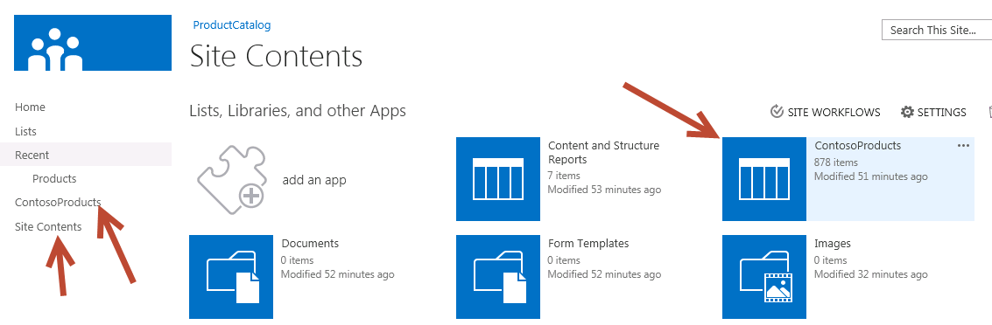

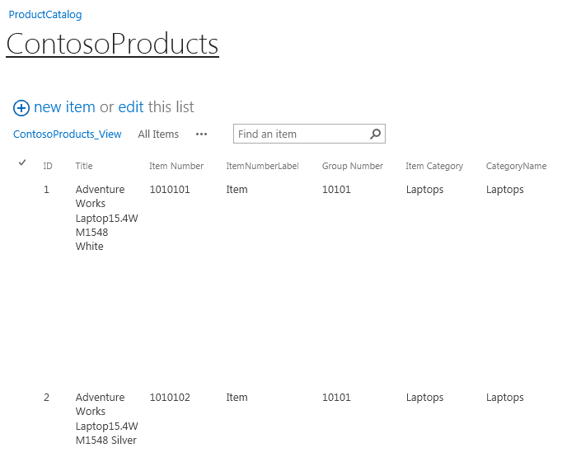

1. Next, ensure the taxonomy was created for the ContosoProducts catalog. Select the gear in the top-right corner of the site and select **Site Settings**.

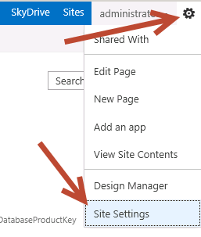

1. On the **Site Settings** page, under the **Site Administration** section, select **Term Store Management**.
2. Verify that a term set called **Product Hierarchy** in the current site collection is present using the **Term Store Management Tool**:

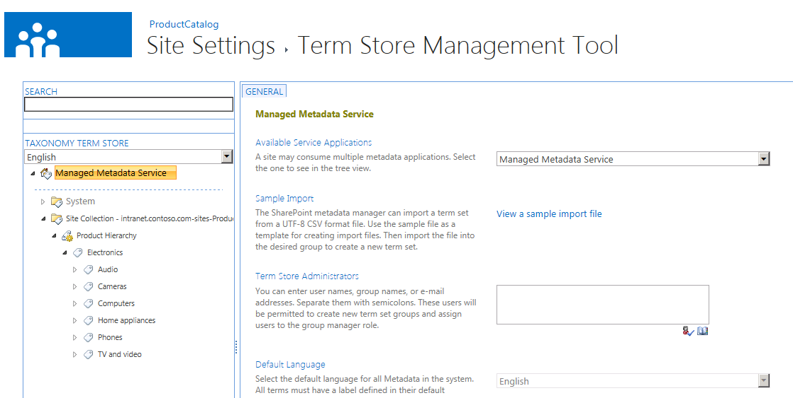

## Step 3 - Configure Search & Managed Properties

In this task you will configure the search service application and create a few managed properties that will be used in a later exercise.

* Begin this task logged on to **SP as CORP\Administrator**.

1. Navigate to Central Administration by selecting **Start 🡪 All Programs 🡪 Microsoft SharePoint 2013 Products → SharePoint 2013 Central Administration**.
2. Under the **Application Management**, select **Manage Service Applications**.
3. Select the service application **Search Service Application**.
4. Before creating managed properties you need to make the search service application aware of all content properties. To do this, you must crawl the content. Start a full crawl of the ContosoProducts catalog:
   * Select **Content Sources** in the left-hand list of links on the **Search Service Application: Search Administration** page.
   * Select the **Local SharePoint Sites** and pick **Start Full Crawl**.

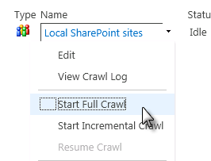

* + This step might take 5-10 minutes depending on the performance of the server you are working on. Click the **Refresh** link at the top of the page to monitor the progress of the crawl.
  + When the crawl is finished, proceed to the next step.

1. Once the content has been crawled you can create a few managed properties that will be used to find the content in the catalog. Select the **Search Schema** link in the left-hand navigation.
2. Create a new managed property by clicking the **New Managed Property** link and using the following information to create it (leave the default values for any selections not specified in the following list) and click **OK** at the end:
   * **Property Name:** ItemId
   * **Type:** Text
   * **Searchable:** Checked
   * **Queryable:** Checked
   * **Retrievable:** Checked
   * **Token Normalization:** Checked
   * **Mappings to Crawled Properties:**

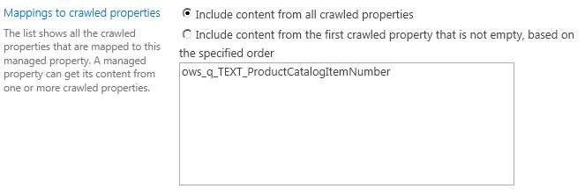

1. Repeat the process to create the following additional managed properties:

|  |  |  |  |
| --- | --- | --- | --- |
| **Property Name** | Category | Price | Color |
| **Type** | Text | Integer | Text |
| **Searchable** | Checked | Checked | Checked |
| **Queryable** | Checked | Checked | Checked |
| **Retrievable** | Checked | Checked | Checked |
| **Token Normalization** | Checked | Checked | Checked |
| **Sortable** | No | Yes – Active | No |
| **Refinable** | Yes – Active | Yes - Active | Yes – Active |
| **Mapping** | ows\_taxId\_ProductCatalogItemCategory | ows\_q\_TEXT\_UnitPrice | ows\_q\_TEXT\_Color |

1. In order to populate the search index with these new managed properties you must re-crawl the content.
   * Select **Content Sources** in the left-hand list of links on the **Search Service Application: Search Administration** page.
   * Select the **Local SharePoint Sites** and pick **Start Full Crawl**.
   * This step might take 5-10 minutes depending on the performance of the server you are working on. Click the **Refresh** link at the top of the page to monitor the progress of the crawl.
   * When the crawl is finished, proceed to the next step.

## Step 4 - Verify Search & Managed Properties are Working

In this task you will create a sample search site and run a few queries to ensure the search service application has indexed the content in the catalog list and populated the managed properties.

* Begin this task logged on to **SP as CORP\Administrator**.

1. Before leveraging the content catalog and search configuration changes in a Publishing site it is recommended you test the contents of the index. Do this by creating a new search site. Navigate <http://intranet.contoso.com>.
2. In **Site Settings**, go to **Site Collection Features** and ensure the **SharePoint Server Publishing Infrastructure** feature is enabled.
3. Select the **Site Contents** link in the **Quick Launch** navigation.
4. On the **Lists, Libraries, and other Apps** page, under the **Subsites** section, select the **new subsite** link.
5. Use the following image to fill in the details in creating a new search site:

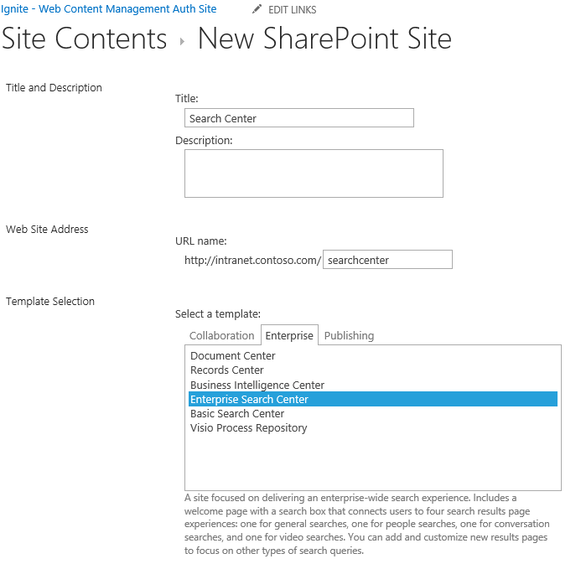

1. After the site is created you will be redirected to the search page. Try a basic keyword search by entering **camera** and press **ENTER** as a search term. You should see the following (or similar) results:

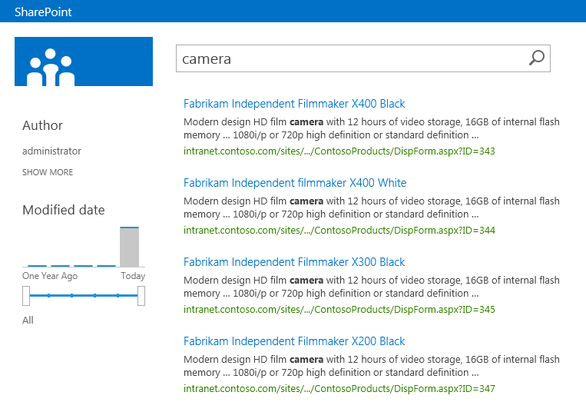

1. Next try a search using the managed properties you previously created by entering a search term such as **category:laptops**

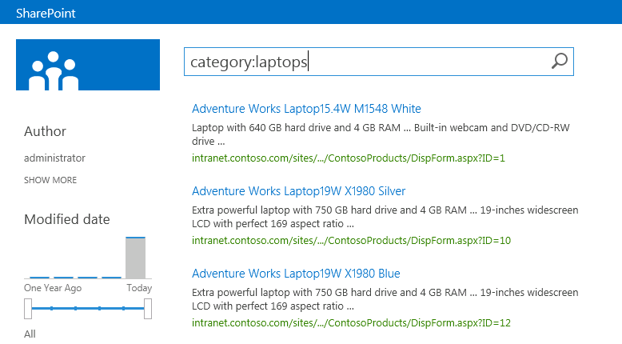

1. Now search for **color:white**:

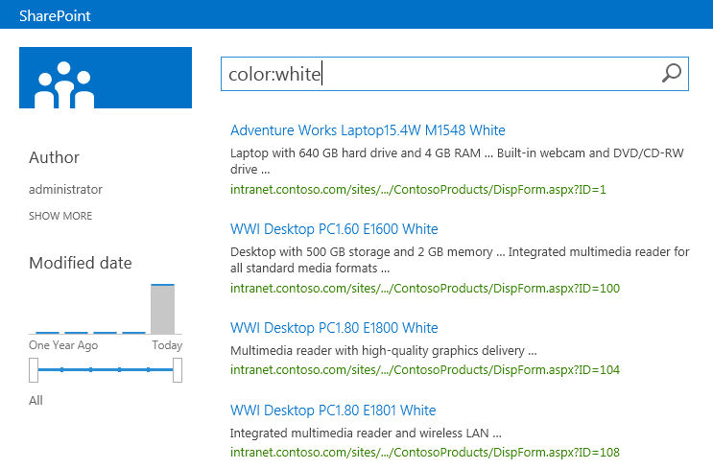

1. Now search for **itemid:1010101:**

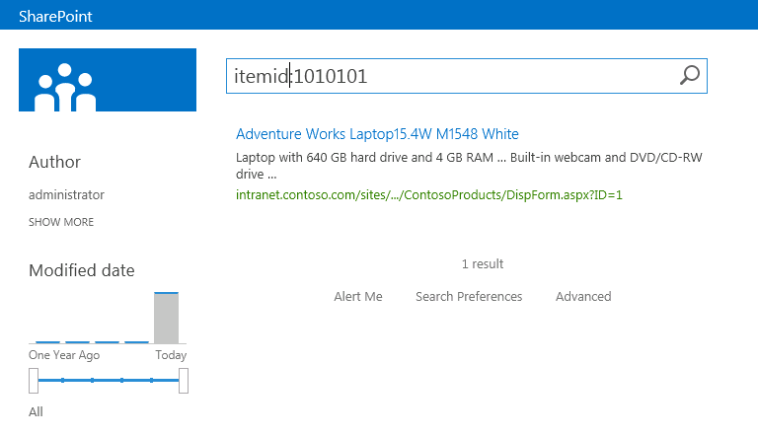

# Create and Populate the Publishing Site with Content

In this demo you will first create a new page manually using the structured authoring method. Next you will configure the content catalog created in the previous exercise for sharing with other site collections.

## Step 1 - Create Content as Structured Authoring

In this task you will create a new page using the new 🡪 page style of content creation (aka: structured authoring) that existing in previous versions of SharePoint and see how pages are added to the navigation automatically.

* Begin this task logged on to **SP as CORP\Administrator**.

1. Open Internet Explorer and navigate to the Publishing site at <http://intranet.contoso.com/sites/wcm>.
2. First add an image to the site to use in a new page:
   * In the **Quick Launch** navigation, click the **Site Contents** link.
   * On the **Site Contents** page, select the **Images** library.
   * Open Windows Explorer (**Start 🡪 All Programs 🡪 Accessories 🡪 Windows Explorer**) and navigate to the location where the files for this demo are stored.
   * Within this folder you’ll find two images in the **Assets** folder. Select both of these files and drag them into the browser near where it says **Drag files here or click to add an item** under the **Images** library title:

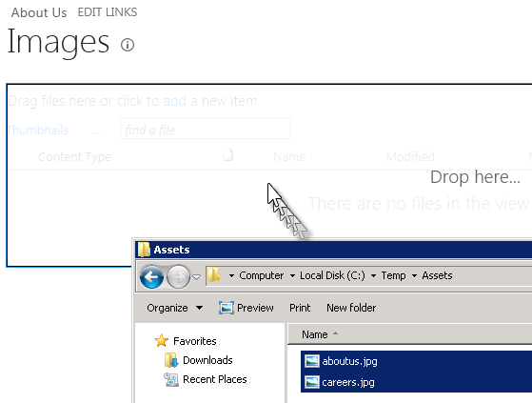

* + After a moment the images will have been uploaded to the library:

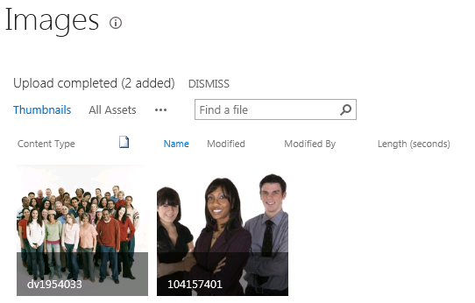

* + After uploading the two images, you need to check them in so they can be used. Do this by selecting the checkbox on each image:

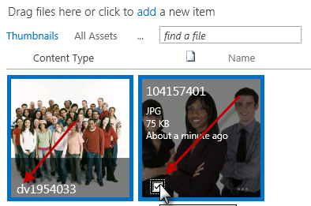

* + Next, select the **Documents** tab in the ribbon and click the **Check In** button:

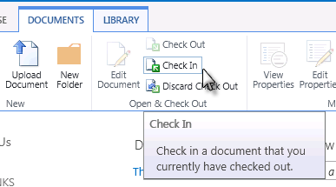

* + When prompted select **Version=Major Version (Publish)** and click **OK**.

1. Next, create a new page using the structured authoring approach in that you will manually create and edit the content on the actual page:
   * Add a new page by clicking the gear in the top-right corner of the page and select **New Page**:

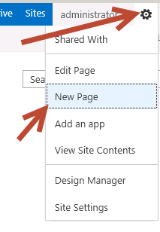

* + In the New Page dialog, enter **About Us** and click **Create**.

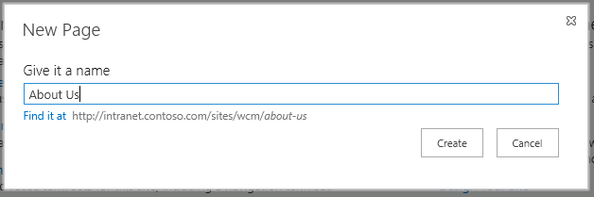

|  |
| --- |
| **C:\Users\vesaj\Pictures\DVD_ART36\Artwork_Imagery\Icons - Illustrations\_ WINDOWS VISTA ICONS\Information more info.png** **Additional Information** |
| *Notice the URL of the page does not include the traditional SharePoint WCM “/Pages” in the URL.* |

* + Enter some text on the page. Use the formatting options under the **Format Text** tab in the ribbon to apply different styles to the text.
  + Add an image to the page by going to the ribbon and selecting the **Insert** tab, then the arrow below the **Picture** button and select **From SharePoint**:

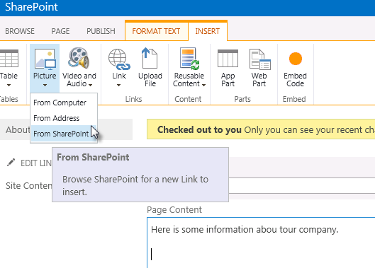

* + Select one of the images you uploaded in a previous step and click **Insert**.

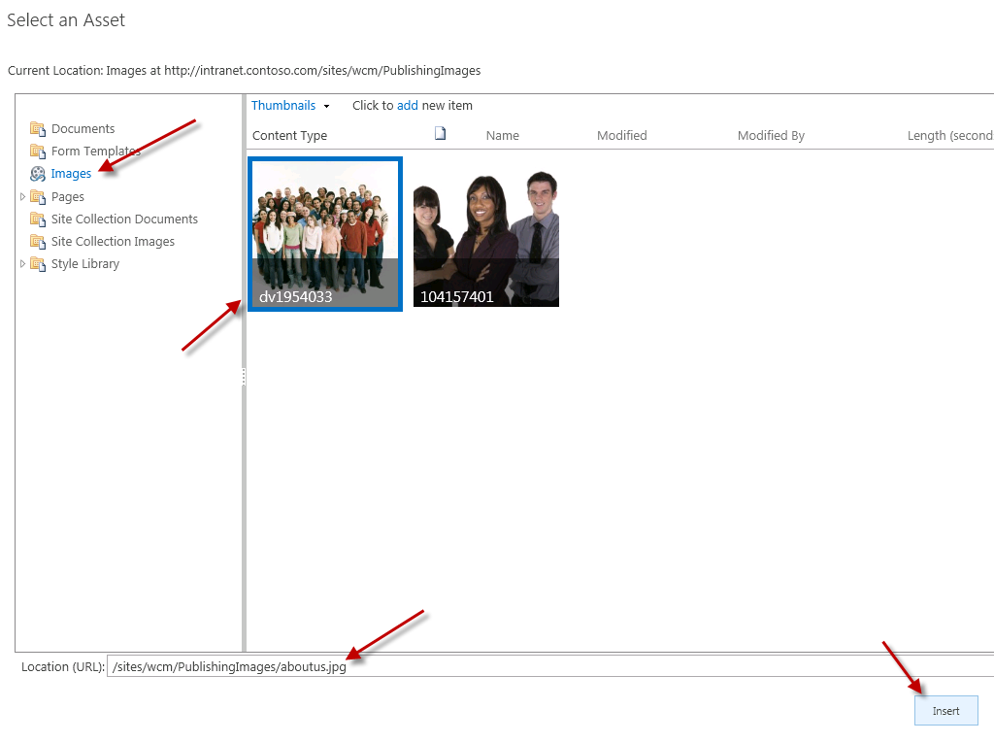

* + Use the picture controls to resize and alter the image.
  + When finished, click the **Check In** button found in the **Page** tab of the ribbon.

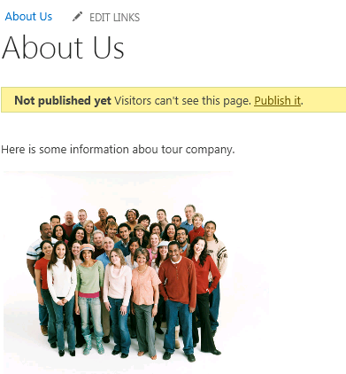

1. Notice how after creating the page the URL is a SEO-friendly URL and the page shows up in the navigation. You can see how the navigation is being created by looking at the site’s navigation taxonomy:
   * Select the gear in the top-right corner of the page and select **Site Settings**.
   * Under the **Site Administration** section, select **Term Store Management**.
   * Expand the term site for the site collection to find the About Us term that is linked to the page you just created:

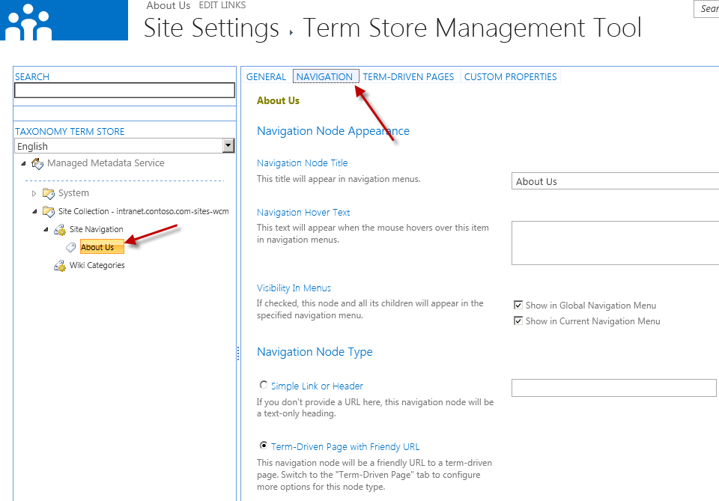

## Step 2 - Share the Product Catalog List

In this task you will share the catalog list you created in the previous exercise.

* Begin this task logged on to **SP as CORP\Administrator**.

1. In order to use the content stored in the ContosoProducts catalog list you must share it so other site collections can connect to it. Using Internet Explorer, navigate to <http://intranet.contoso.com/sites/ProductCatalog>.
2. Select the **Site Conents** link in the **Quick Launch** navigation and select the **ContosoProducts** list.
3. Go to the list’s settings by selecting the **List** tab in the ribbon and then the **List Settings** button.
4. On the List Settings page, select Catalog Settings under the **General Settings** column:

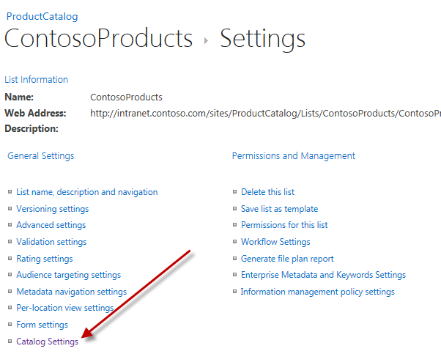

1. On the **Catalog Settings** page, select the following options and click **OK**:
   * **Catalog Sharing:** Checked
   * **Primary Key:** Item Number
   * **Catalog Navigation:** Item Category

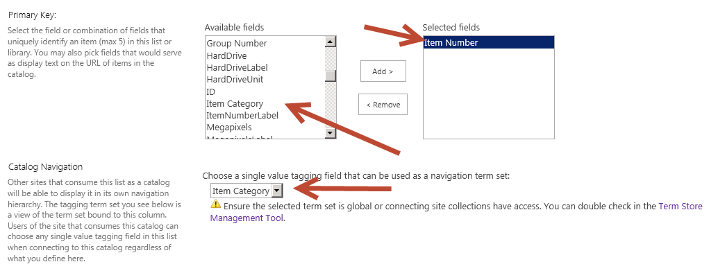

## Step 3 - Connect the Catalog to the Publishing Site and Enable Managed Navigation

In this task you will connect the catalog to the Publishing site and configure the managed navigation so the Publishing site’s

* Begin this task logged on to **SP as CORP\Administrator**.

1. The site collection that contains the ContosoProducts catalog list also contains a term set that should be used for navigation in the Publishing site. In order to use the term set in another site collection it must be shared. Using Internet Explorer, navigate to <http://intranet.contoso.com/sites/ProductCatalog>.
2. Next, use the gear icon in the top-right corner to select the **Site Settings** option.
3. Select the **Term Store Management** option under the **Site Administration** section.
4. Select the Site Collection grouping for the current site collection as shown in the following figure:

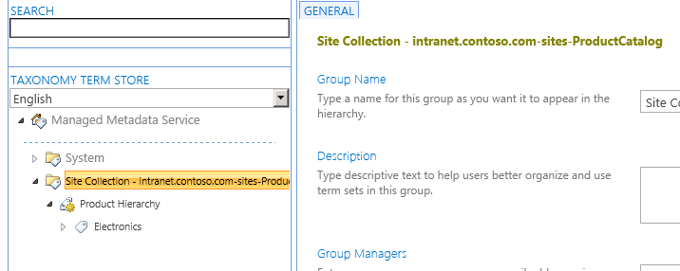

1. Next, enter the URL of the Publishing site collection (<http://intranet.contoso.com/sites/wcm>) to share the term set with in the **Site Collection Access** box and click **Save**:

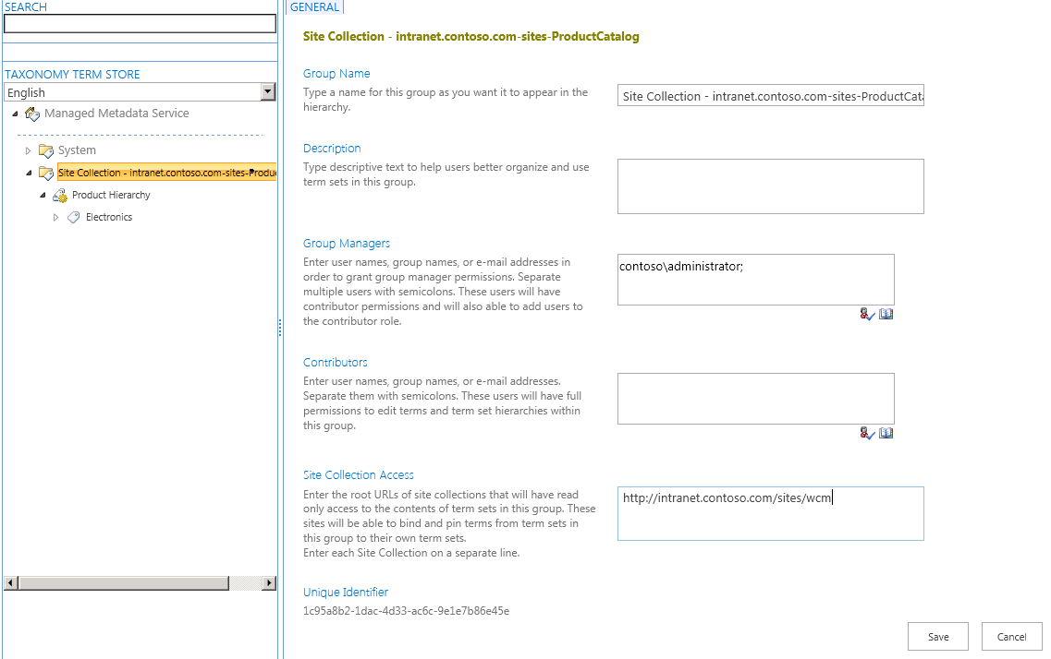

1. Verify the term set is available in the Publishing site. Using Internet Explorer, navigate to <http://intranet.contoso.com/sites/wcm>.
2. Using the gear icon in the top-right corner, go to the **Site Settings** page.
3. Under the **Site Administration** section select **Term Store Management**.
4. Notice that the term set’s site collection is showing up in the Publishing site.

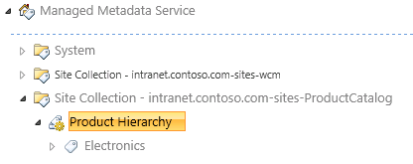

# Implement Managed Navigation

In this demo you will connect it to the Publishing site and enable managed navigation on the Publishing site.

## Step 1 - Share the Catalog’s Term Set with the Publishing Site

In this task you will ensure the catalog created in a previous demo is shared for use in the Publishing site.

* Begin this task logged on to **SP as CORP\Administrator**.

1. With the ContosoProducts catalog list shared, you now need to connect the Publishing site to the catalog. Using Internet Explorer, navigate to <http://intranet.contoso.com/sites/wcm>.
2. Using the gear icon in the top-right corner, go to the **Site Settings** page.
3. Under the Site Administration section, select **Manage Catalog Connections**.
4. Click the link **Connect to a Catalog**.
5. The **ContosoProducts** catalog should be listed. Click the **Connect** link on the right:

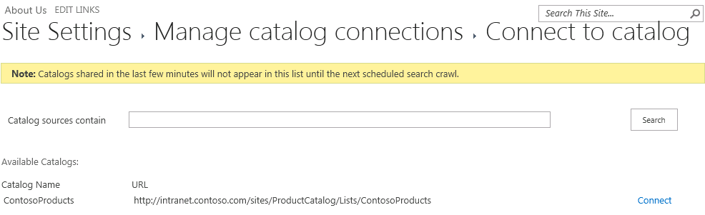

|  |
| --- |
| Description: note_dd**Note** |
| *If the catalog is not shown here, go back to the Search Service Application in Central Administration and restart a full index of the content source as shown in previous steps.* |

1. On the **Catalog Source Settings** page, select the following options and click **OK**:
   * **Connection Integration:** Integrate the catalog into my site
   * **Navigation Hierarchy:** 
     1. **Select column that categorizes items for navigation:** Item Category
     2. **Root term of hierarchy:** Electronics
   * **Navigation Position:** Add to navigation root
   * **Navigation Pinning:** Pin Terms to site navigation
   * **Catalog Item URL Behavior:** Make URLs relative to this site
   * **Catalog Item URL Format:**
     1. **Construct a URL format from catalog properties:** Checked
     2. **Primary Key Fields:** ItemId
   * **Category Page:** Create a new page
   * **Item Page:** Create a new page
2. Notice that after the page loads, the navigation is now reflecting not only the page manually created but also the items from the term set:

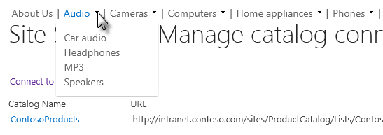

1. You can see the contents being pulled back automatically but selecting from the navigation **Computers 🡪 Laptops**:

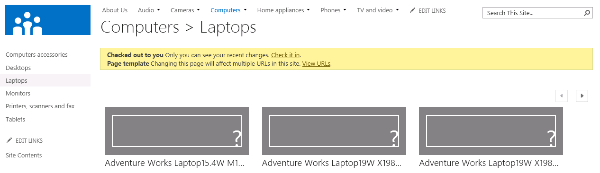

# Customize Rollup and Detail Pages with the Content by Search Web Part

In this demo you will customize the rollup and detail pages using the new Content by Search Web Part.

## Step 1 – Create New Rollup Page Templates

When you connected the Publishing site to a catalog, SharePoint automatically created page layouts for use as the rollup and detail pages. In this step you will replace them with new ones.

* Begin this task logged on to **SP as CORP\Administrator**.

1. Using Internet Explorer, navigate to <http://intranet.contoso.com/sites/wcm>.
2. Using the gear icon in the top-right corner, select **Site Settings**.
3. Under the **Web Designer Galleries**, select **Master Pages and Page Layouts**.
4. Upload the file **ContosoRollup1Column.aspx** found in the **Assets\Page Layouts** in the location where the files for this demo are stored
5. When prompted, accept all default except the following fields:
   * **Content Type Group:** Page Layout
   * **Content Type Name:** Catalog-Item Reuse
6. Repeat the steps above for **ContosoRollup2Columns.aspx**.
7. Using the gear icon in the top-right corner, select **View Site Contents**.
8. On the **Lists, Libraries, and other Apps** page, select the **Pages** library.
9. Using the ribbon, select the **Files** tab, click the down arrow on the **New Document** button and select **Catalog-Item Reuse**.

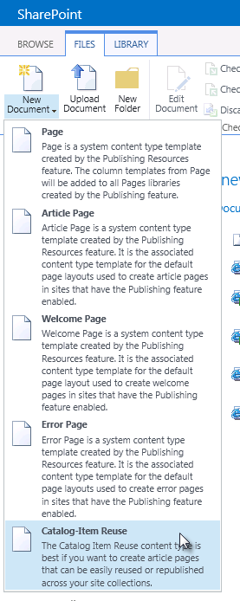

1. On the **Create Page** page, use the following to complete the form and click **Create**:
   * **Title:** Main Category
   * **URL Name:** MainCategory.aspx
   * **Page Layout:** (Catalog-Item Reuse) ContosoRollup1Column.aspx

## Step 2 – Associate Category Pages with the new Rollup Page Template

In this step you will set the category notes to use the new rollup page you just created.

* Begin this task logged on to **SP as CORP\Administrator**.

1. Using Internet Explorer, navigate to <http://intranet.contoso.com/sites/wcm>.
2. Using the gear icon in the top-right corner, select **Site Settings**.
3. Under the **Site Administration** section, select **Term Store Management**.
4. Expand the **Site Collection – intranet.contoso.com-sites-wcm** node and the **Site Navigation** node.
5. Select the **Audio** node

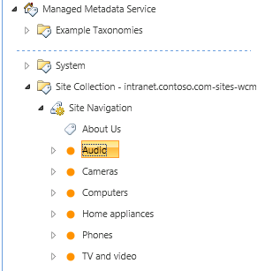

1. In the right-hand pane, select the **Navigation** tab.
2. Next, in the **Navigation Node Type** section, select **Term-Driven Page with Friendly URL**.

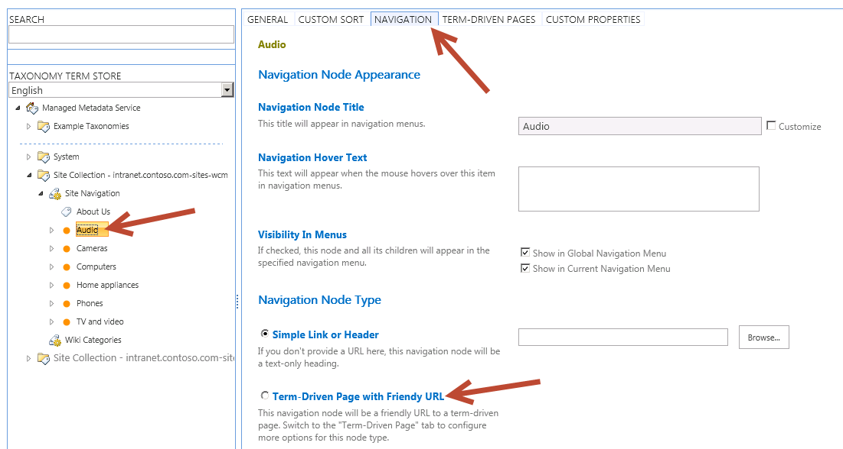

1. Then scroll to the bottom and click **Save**.
2. Next, select the **Term-Driven Pages** tab.
3. Under the **Target Page Settings**, check both of the following options and select the **/sites/wcm/Pages/MainCategory.aspx** page as the template to use:
   * Change target page for this term
   * Change target page for children of this term

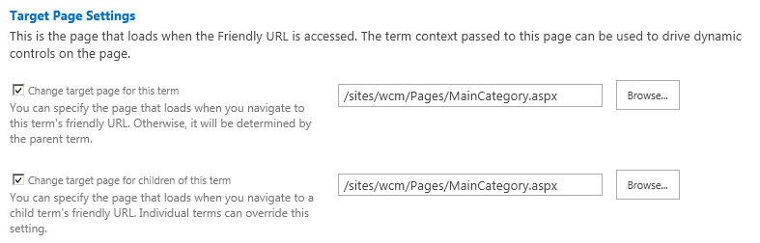

1. Scroll to the bottom and click **Save**.
2. Repeat these steps for the other top-level categories in the navigation: **Cameras**, **Computers**, **Home Appliances**, **Phones** and **TV and Video**.

## Step 3 – Ensure the Content by Search Web Part is Available

In this step you will verify the Content by Search Web Part is available in this site collection.

* Begin this task logged on to **SP as CORP\Administrator**.

1. Using Internet Explorer, navigate to <http://intranet.contoso.com/sites/wcm>.
2. Using the gear icon in the top-right corner, select **Site Settings**.
3. Under the **Site Collection Administration** section, select **Site Collection Features**.
4. If the **SharePoint Server Enterprise Site Collection Features** feature is not activated, click the **Activate** button.

## Step 4 – Customize the Main Category Page

In this step you will now customize the main category page you have created and configured to be used for the navigation rollup pages.

* Begin this task logged on to **SP as CORP\Administrator**.

1. Using Internet Explorer, navigate to <http://intranet.contoso.com/sites/wcm>.
2. In the top-navigation, select **Audio**.
3. The page should load with no content. Now you will modify the template all pages use to dynamically show content based on the URL of the page.

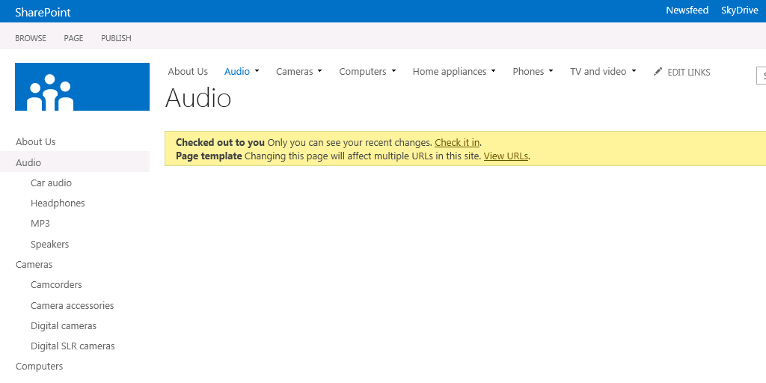

1. Using the gear icon in the top-right corner, select **Edit Page**.
2. When prompted, select **Edit Page Template**. It will warn you how many URLs will be affected by this change:

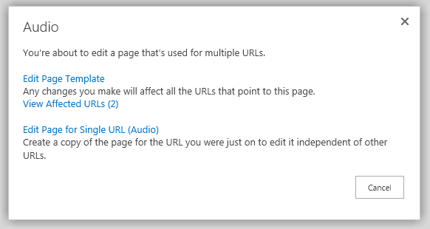

1. Click **Add a Web Part**.
2. From the **Content Rollup** category, select **Content Search** and click **Add**.

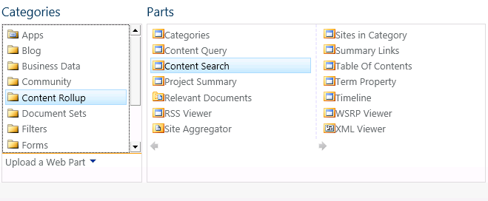

1. Select the Web Part that was added to the page and from the ribbon, select the Web Part contextual tab and then the Web Part Properties button:

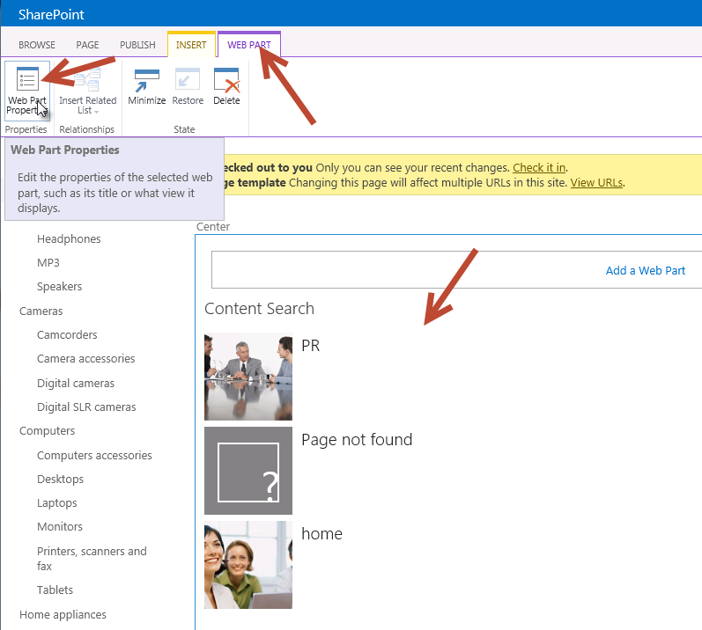

1. In the Editor Tool Pane on the right-hand side of the page, click the **Change** button under **Search Criteria**:

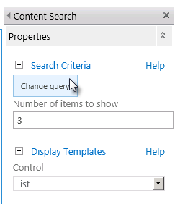

1. Use the following settings to filter the results & notice how the results change to the right of the page.
   * **Select a query:** ProductCatalog – ContosoProducts Results (Site Collection)
   * **Restrict by tag:** Restrict by current and sub-page navigation terms

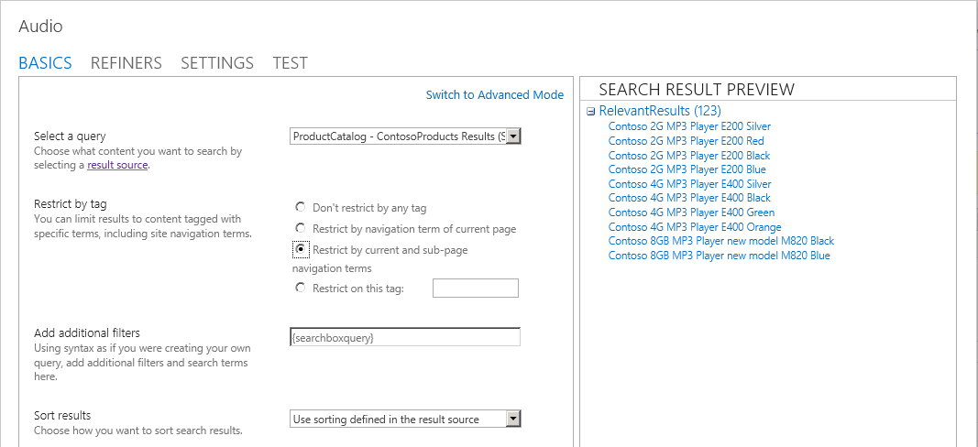

1. Click **OK** to close the query builder.
2. In the Editor Tool Pane, change the **Number of Items to Show** to be **9**, set the **Display Template** for **Item** to be **Picture on top, 3 lines on bottom** and click **OK** to apply all changes.
3. Finally, in the ribbon, click Check In to save the changes to the page to see the new rollup page:

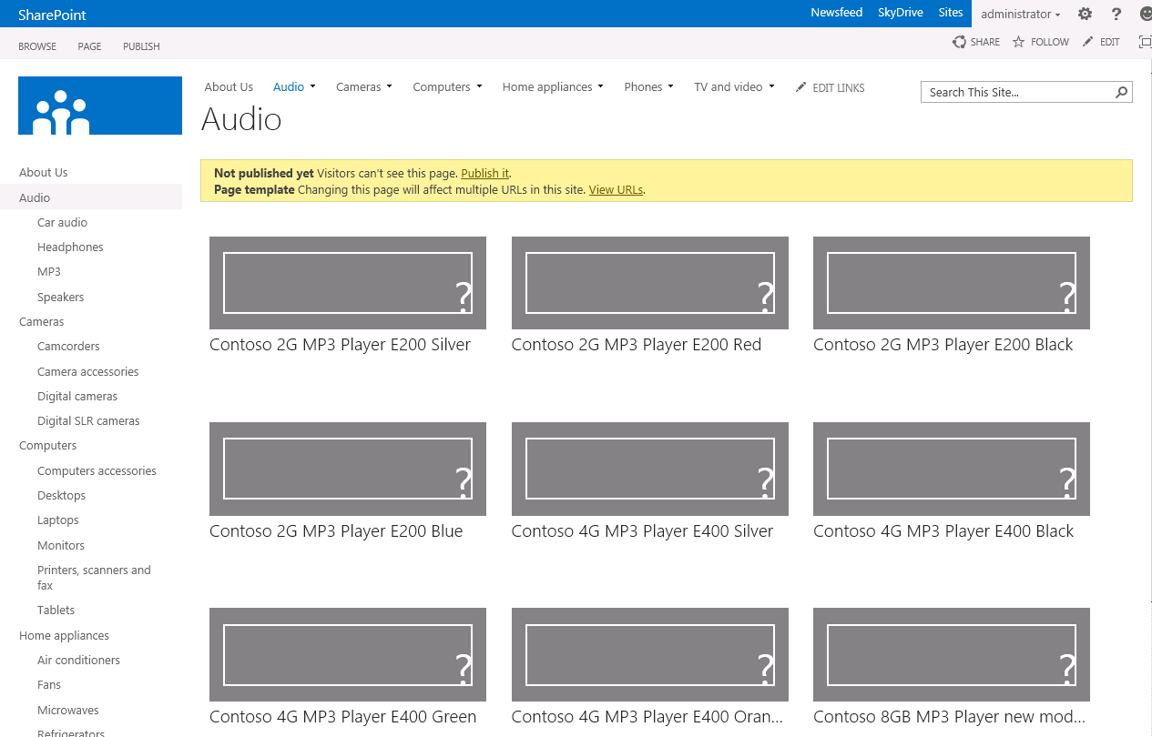

1. If you click on **Cameras**, you’ll notice it has the same changes applied to it.

* This is the end of the demo